Name: _________________ Mrs. Moore-English 7
Final Exam: Thursday, June 19, 2018: 12:15-2:15 pm

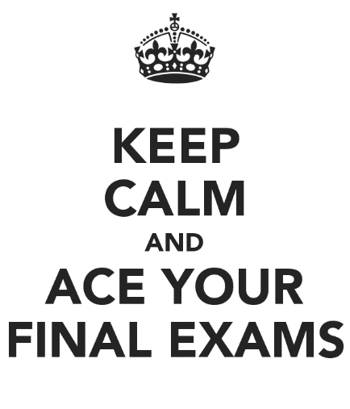
English 7 Skills Final Exam Review Guide
The English final exam is in three parts:
- It begins with an engaging reading with questions that require you to read carefully.
- You will then answer questions about some of the literature you read this year.
- The exam will end with questions on vocabulary and grammar.

Be prepared to:
- Read carefully! Go back to the text and use the numbered paragraphs to find the right section to read again. This is very important!
- Infer from the text. Draw conclusions about what you are reading. The answers are not always “right there.” You need to gather details and come up with a conclusion based on the text.
- Understand details and select the “best answer” given. Some are “all of the above,” so read each choice carefully!
- Identify the mood or tone of a text. Find details that add to the mood or tone.
- Determine the meaning of several words through context. (Notice that underlined words are important.) Try to understand their meaning through context as you read.
- Find details to support a statement.
- Determine the theme or main idea of a text.
- Understand the structure of a text: main idea/details, cause/effect, the development of an idea.

Literature Packets/Stories/Tests to Review :
- The Watsons Go To Birmingham-1963 by Christopher Paul Curtis
- The Cay by Theodore Taylor
- “A Retrieved Reformation” by O. Henry
- “After Twenty Years” by O. Henry
- “The Monsters Are Due on Maple Street” by Rod Serling
- Langston Hughe’s Poem : “To You”
- Emily Dickinson’s Poem: “If I Can Stop One Heart From Breaking”

Name _________________________ Final review

Directions: Match the Literary term on the left with its definition on the right

__________ 1. simile a) uses exaggeration in order to get a laugh,
make a point, or persuade

__________ 2. metaphor b) the giving of human qualities to an animal,object
or idea

__________ 3. fiction c) when and where a story takes place

__________ 4. setting d) a form of literature that tells about imaginary
people, places or events; not real

__________ 5. nonfiction e) a comparison of two unlike things without using
the words “like” or “as”

__________ 6. personification f) writing that tells about real people, places and
events

__________ 7. hyperbole g) a comparison between two different things using
the words “like” or “as”

__________ 8. alliteration h) a message or lesson about life

__________ 9. onomatopoeia i) some examples of this are: Zoom! Snap, crackle,
pop! Tlot-tlot!

__________ 10. theme j) repetition of the initial consonant sound (for
example: The highway man came riding, riding, riding.

Name _________________________ Final review: Proofreading/Grammar

Directions: Rewrite the following sentences, making all the necessary corrections in capitalization and punctuation. There are SIX (6) mistakes in each sentence.

1. many battles took place in new york during the revolutionary war

- jonathans mother, the football coach, drive’s a chevy corvette

- Did the giants won gaim against the cowboys

________________________________________________________________________

4. Tom sayed, This final Exam is’nt to hard!

5.You’re eye’s is as blew as the ocean is a example of an simile.

Name______________________ Final review: Cold Read

The Mysterious Island

By Jules Verne

After being suspended for an instant aloft, the balloon began to descend again, gas escaping from the large tear in its fabric. The five men had done all that men could do. No human efforts could save them now. At four o’clock they were only five hundred feet above the surface of the water.
The balloon, which the wind had driven southwest since daybreak, was still nearly thirty miles from the tiny island. The voyagers could distinctly see that solid spot which they must reach at any cost, whether inhabited or desolate, whether hospitable or not.
It was evident that the balloon could no longer support itself. Several times already the crests of enormous waves had licked the bottom of the net, making it still heavier. The balloon only half rose, like a bird with a wounded wing. It plunged into the sea again and the travelers were beaten by the furious waters. The balloon case bulged once more, and the wind taking it, drove it along like a ship. Suddenly, after having been struck by a tremendous sea, it made an unexpected bound, met a current of wind, and mounted to a height of fifteen hundred feet._____________________________________
“Several times already the crests of enormous waves had licked the
bottom of the net, making it still heavier.”
__________1. What type of figurative language is being used in this sentence?
a) simile b) hyperbole
c) metaphor d) personification

“The balloon only half rose, like a bird with a wounded wing.”
__________ 2. What type of figurative language is being used in this sentence?
a) simile b) hyperbole
b) metaphor d) personification

__________ 3. When the author compares the balloon to a wounded bird, he means that-
- it has a leak c) it is crying out in pain
- it is getting frenzied d) it cannot fly very well

__________ 4. When the author describes the waters as “furious,” he means they are-
a) slightly choppy c) rough and wavy
b) still and smooth d) flowing quickly

