***Birmingham, Alabama, and the Civil Rights Movement in 1963***

***The 16th Street Baptist Church Bombing***

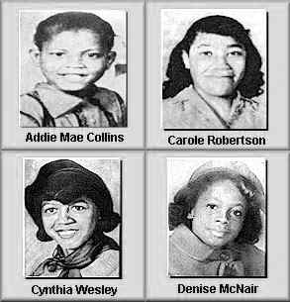The Sixteenth Street Baptist Church in Birmingham was used as a meeting-place for civil rights leaders such as Martin Luther King, Ralph David Abernathy and Fred Shutterworth. Tensions became high when the Southern Christian Leadership Conference (SCLC) and the Congress on Racial Equality (CORE) became involved in a campaign to register African American to vote in Birmingham.

On Sunday, 15th September, 1963, a white man was seen getting out of a white and turquoise Chevrolet car and placing a box under the steps of the Sixteenth Street Baptist Church. Soon afterwards, at 10.22 a.m., the bomb exploded killing Denise McNair (11), Addie Mae Collins (14), Carole Robertson (14) and Cynthia Wesley (14). The four girls had been attending Sunday school classes at the church. Twenty-three other people were also hurt by the blast.

Civil rights activists blamed George Wallace, the Governor of Alabama, for the killings. Only a week before the bombing he had told the New York Times that to stop integration Alabama needed a "few first-class funerals."

A witness identified Robert Chambliss, a member of the Ku Klux Klan, as the man who placed the bomb under the steps of the Sixteenth Street Baptist Church. He was arrested and charged with murder and possessing a box of 122 sticks of dynamite without a permit. On 8th October, 1963, Chambliss was found not guilty of murder and received a hundred-dollar fine and a six-month jail sentence for having the dynamite.

**"****The Day The Children Died" People Magazine  
by Kyle Smith, Gail Cameron Wescott in Birmingham and David Cobb Craig in New York City Photographs by Ann States/SABA**

**SUNDAY SCHOOL HAD JUST LET OUT,** and Sarah Collins Cox, then 12, was in the basement with her sister Addie Mae, 14, and Denise McNair, 11, a friend, getting ready to attend a youth service. "I remember Denise asking Addie to tie her belt," Cox, now 46, says in a near whisper, recalling the morning of Sept. 15, 1963. "Addie was tying her sash. Then it happened." A savage explosion of 19 sticks of dynamite stashed under a stairwell ripped through the northeast corner of the Sixteenth Street Baptist Church in Birmingham, Alabama. "I couldn't see anymore because my eyes were full of glass - 23 pieces of glass," says Cox. "I didn't know what happened. I just remember calling, 'Addie, Addie.' But there was no answer. I don't remember any pain. I just remember wanting Addie."

That afternoon, while Cox's parents comforted her at the hospital, her older sister Junie, 16, who had survived the bombing unscathed, was taken to the University Hospital morgue to help identify a body. "I looked at the face, and I couldn't tell who it was," she says of the crumpled form she viewed. "Then I saw this little brown shoe - you know, like a loafer - and I recognized it right away."

Addie Mae Collins was one of four girls killed in the blast. Denise McNair; Carole Robertson, 14; and Cynthia Wesley, 14, also died, and another 22 adults and children were injured. Meant to slow the growing civil rights movement in the South, the racist killings, like the notorious murder of activist Medgar Evers in Mississippi three months earlier, instead fueled protests that helped speed passage of the 1964 Civil Rights Act.

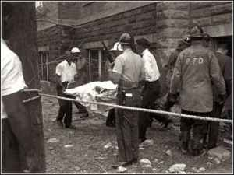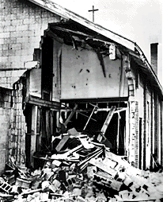

http://norunnyeggs.com/wp-content/uploads/2008/07/birmingham2.jpg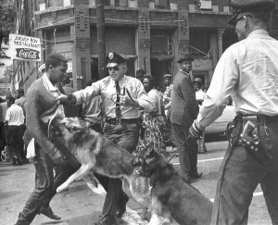

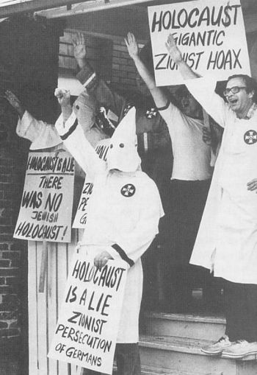 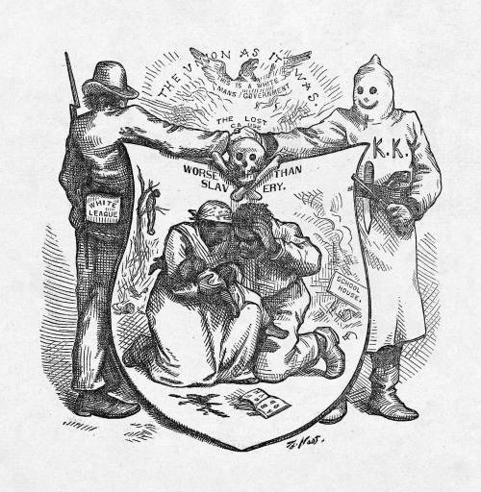

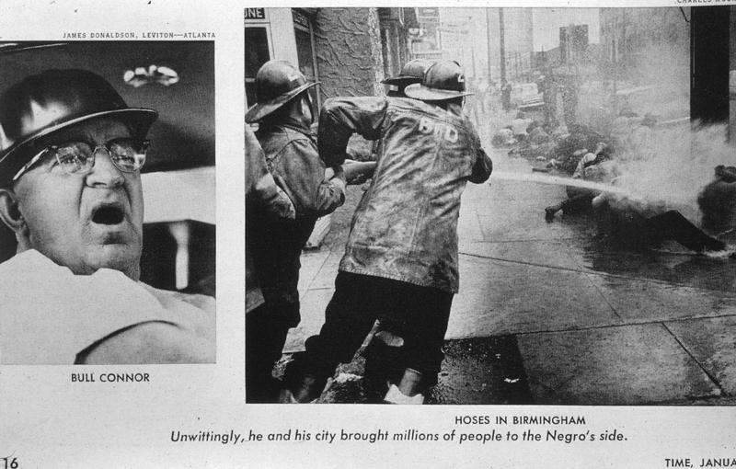

As the Public Safety Commissioner of [Birmingham, Alabama](http://en.wikipedia.org/wiki/Birmingham,_Alabama), in the 1960s, Connor became a symbol of [bigotry](http://en.wikipedia.org/wiki/Bigotry). He infamously fought against integration by using [fire hoses](http://en.wikipedia.org/wiki/Fire_hose) and police [attack dogs](http://en.wikipedia.org/wiki/Attack_dog) against protest marchers. His aggressive tactics backfired when the spectacle of the brutality being broadcast on national [television](http://en.wikipedia.org/wiki/Television) served as one of the catalysts for major social and legal change in the South and helped in large measure to assure the passage by the [United States Congress](http://en.wikipedia.org/wiki/United_States_Congress) of the [Civil Rights Act of 1964](http://en.wikipedia.org/wiki/Civil_Rights_Act_of_1964).