Name ________________________________________ Date ______________
French and Indian War Period ____________
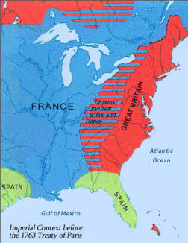
As more British settlers came to North America, they started to travel west over the Appalachian Mountains and settling into the Ohio River Valley. France had already settled that region and had a profitable fur trade business. They worked well and lived peacefully with the Native Americans in the region. The British settlement of the Ohio River Valley eventually led to fighting breaking out in America.
- What land were the British and French fighting over? ______________________________________________________
______________________________________________________
______________________________________________________
The British had a long history of treating Native Americans poorly. As far back as Jamestown, the British often raided and claimed the lands of Native Americans. The French had positive relations with the Natives and had since the French came to settle in the Americas in the 1600s. Therefore, when fighting broke out in the Ohio River Valley, the Native Americans allied with the French and fought against the British. An ally is a nation that joins with another nation to fight for the same cause. The Natives felt it was better to trade with the French than to lose their land to British settlers. For this reason, the war became known as the French and Indian War.
- What is an ally? ________________________________________________________________________________________________________________________________________________________________________
- Why did the Natives ally with the French instead of the British? ____________________________________________________________________________________________________________________________________________________________________________________________________________________________________________________________
The Natives taught the French a strategic way of fighting called guerilla warfare. This type of fighting used surprise attacks, and shooting from hiding places. Their battle clothes could not be easily seen. This style of fighting proved to be effective against the British who dressed in bright red uniforms and marched in large groups into battle. The French and Indians were winning the war at first because of guerilla warfare.
- Who was winning the war at first and why? ____________________________________________________________________________________________________________________________________________________________________________________________________________________________________________________________

