#_________
NAME:__________________________________ DATE:_____________________
CLASS PERIOD: _________ ENGLISH 7: Mrs. Moore

“Rikki-tikki-tavi”
by Rudyard Kipling

Reading Guide

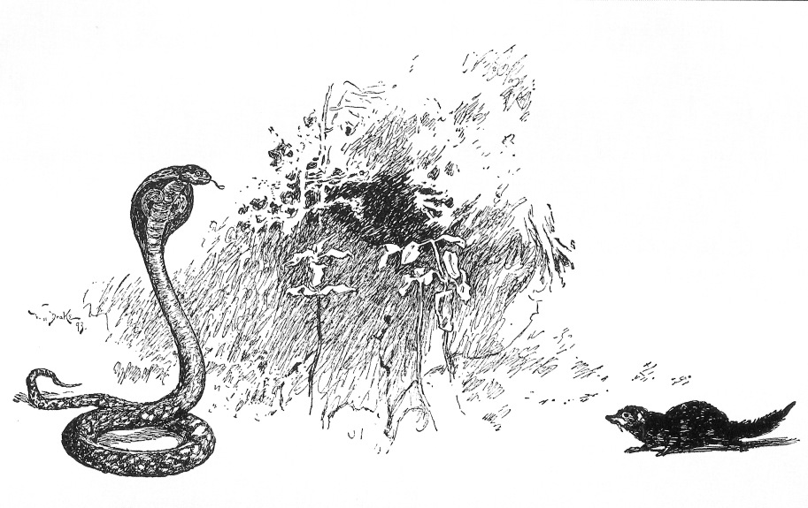
Making Predictions
DIRECTIONS: As you read “Rikki-tikki-tavi,” pause after each event listed in the “Events” column to make a prediction. Write your prediction in the “Predictions” column. When you find out what actually happens, write it in the “What Actually Happens” column.

Event | Predictions | What Actually Happens
1. Teddy’s parents see Rikki-tikki on Teddy’s pillow.
2. Rikki-tikki meets Nag in the garden.
3. Rikki-tikki meets Karait in the garden.
4. Nag sneaks into the house at night.
5. Darzee’s wife pretends to have a broken wing.
6. Rikki-tikki is pulled down into Nagaina’s hole.

Literary Elements: Plot Map
DIRECTIONS: As you read “Rikki-tikki-tavi,” record all important events of the story on this plot map.

Main Characters
Continued on next page
Major Conflict
Events Leading up to Major Conflict (list by numbered order)
1.
Plot Complications (list by numbered order)
1.
Climax
Resolution
Literary Devices: Personification
DIRECTIONS: In the story, Kipling personifies, or gives human traits to, animals. As you read, complete the chart below. Identify the type of animal each character is, the animal’s traits, and the key actions or words you used to find those traits.
Animal’s Name | Type of Animal | Personality Traits | Key Actions or Words
Rikki-tikki-tavi | Mongoose | Confident, curious, brave, clever | Fights all snakes, plots to kill cobras, protects family.
Darzee
Darzee’s Wife
Chuchundra
Nag
Nagaina

Reading Comprehension Questions
DIRECTIONS: As you read “Rikki-tikki-tavi,” answer the following questions.
- SECTION A: Questions for pgs. 143-147 of “Rikki-tikki-tavi”
1. Kipling reveals the setting of the novel slowly as the story progresses. List at least five facts about the setting of this story.

2. What does Rikki-tikki-tavi say is the motto of the mongoose family, and how does he follow this motto and show that he is a true mongoose?

3. Why are Darzee and Darzee’s wife so sad when Rikki-tikki first meets them?

4. Briefly describe Rikki-tikki’s first meeting with Nag and Nagaina.

- SECTION B: Questions for pgs. 148-152 of “Rikki-tikki-tavi”
1. How did Rikki-tikki first become a hero, and how was he treated after his encounter with Karait?

2. Who warns Rikki-tikki of Nag and Nagaina’s plan and how is this creature characterized by Kipling?

3. Briefly describe the events that led up to Nag’s death.

4. Why does Rikki-tikki need to find Nagaina’s nest, and why do you think Darzee is reluctant to help him?

5. How does Rikki-tikki make sure that Nagaina is distracted long enough for him to find her nest? Does this diversion work?

- SECTION C: Questions for pgs. 153-156 of “Rikki-tikki-tavi”
1. Rikki-tikki destroys Nag and Nagaina’s eggs, even though he was appalled that Nag ate one of Darzee’s fledglings. Are Rikki-tikki’s actions justified, or is he being a hypocrite?

2. How does Rikki-tikki lure Nagaina away from the family?

3. Why is it so dangerous for Rikki-tikki to follow Nagaina into her hole? What do Rikki-tikki’s friends think will happen to him underground?

4. Rikki-tikki has killed Karait, Nag, and Nagaina, as well as Nagaina’s babies. Were Rikki-tikki’s actions justified, or was he just a murderer? Why do you think so?

Literary Devices: Adding Style
DIRECTIONS: Match the following literary devices to their examples from Rudyard Kipling’s “Rikki-tikki-tavi.”

_____1. ONOMATOPOEIA

_____2. SIMILE

_____3. METAPHOR

______4. ALLITERATION

______5. IMAGERY

______6. PERSONIFICATION

A. “…and his war cry as he scuttled through the long grass was Rikk-tikk-tikki-tikki-tchk!” (pg. 143)

B. “They had made a beautiful nest by pulling two big leaves together and stitching them up the edges with fibers and had filled the hollow with cotton and downy fluff.” (pg. 145)

C. Karait said “Be careful. I am Death!” (pg. 147)

D. “Chuchundra sat down and cried till the tears rolled off his whiskers. ‘I am a very poor man,’ he sobbed.” (pg.149)

E. “Darzee was a featherbrained fellow who could never hold more than one idea at a time in his head…” (pg. 152)

F. “When a cobra runs for her life, she goes like a whiplash flicked across a horse’s neck.” (pg. 154)

“Rikki-tikki-tavi” Acrostic Poem
And Literary Device Project
DIRECTIONS: Choose one of the following characters from Kipling’s short story, “Rikki-tikki-tavi” and compose an acrostic poem representing the character. Using correct acrostic poem format is not the only requirement of this project, however. You must also include examples of literary devices in your poem. See below for project requirements! (This project is worth 20 points)
- Step 1: Choose from the following characters:
  - Rikki-tikki-tavi
  - Darzee
  - Darzee’s Wife
  - Nag and Nagaina
  - Nagaina
  - Chuchundra
    - NOTE: If you would like to write your poem on Nag, you MUST use “Nag and Nagaina” because Nag is too short!

- Step 2: Using the story as inspiration, write an acrostic poem that displays your character’s personality and role in the story. Besides using the story as your inspiration, your poem MUST contain at least one example of the following literary devices.
  - Alliteration (UNDERLINE the first letters of the alliterative words in RED)
  - Simile (HIGHLIGHT your simile in YELLOW)
  - Metaphor (UNDERLINE your metaphor one time in BLUE)
  - Onomatopoeia (CIRCLE your onomatopoeia in PURPLE)
  - Imagery (Place a GREEN BOX around your example of imagery)
  - Personification (UNDERLINE your example of personification in BLACK)

    - You must use each literary device properly and LABEL it within your poem as specified by the directions in parentheses following each literary device!

- Step 3: Format your acrostic. The character’s name will be typed vertically down the left side of the page. Your acrostic MUST be typed, but the font style and size is up to you. You may also include clip art or original drawings on your finished product to enhance your poem!
Example

Nag’s scheming spouse.
All creatures great and small fear her sharp hiss.
Grabbed her egg and fled for her life into her hole.
A cold-blooded killer.
Is as treacherous as snake-haired Medusa.
Not exactly the type of neighbor you’d want living next door.
At the end, she gets what she deserves!

